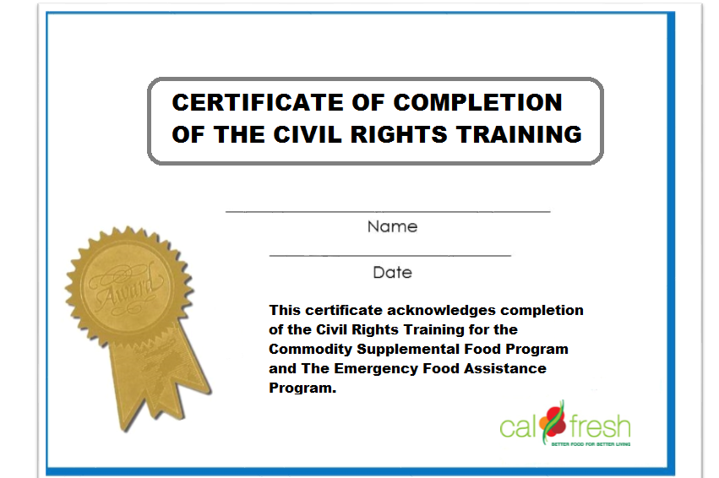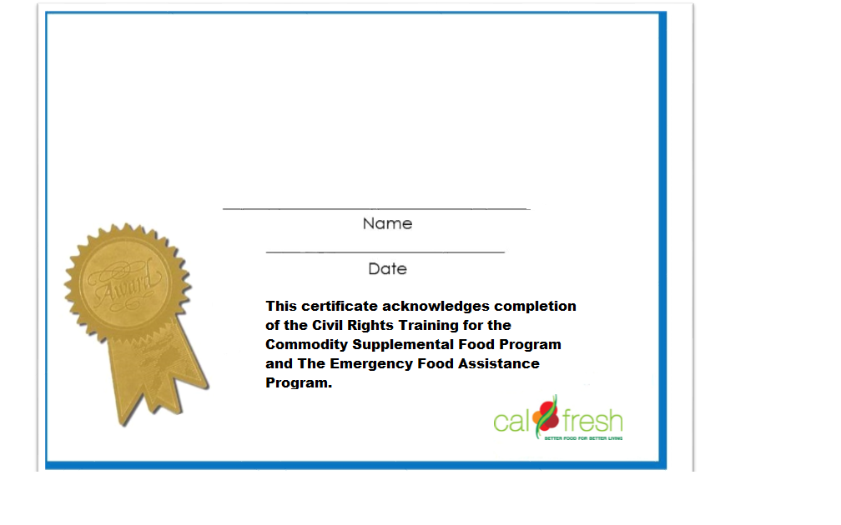

Click or tap here to enter text.

Click or tap here to enter text.

Agency

Click or tap here to enter text.